

<<TITLE OF THE PROJECT>>

INNOVATIVE DESIGN LAB – II

A Report

Submitted by
<Student name1 in caps> | (Reg no)
<Student name2 in caps> | (Reg no)

in partial fulfillment for the award of the degree of
BACHELOR OF ENGINEERING /
BACHELOR OF TECHNOLOGY

in

DEPARTMENT OF XXX

SRI SAIRAM ENGINEERING COLLEGE

(An Autonomous Institution; Affiliated to Anna University, Chennai -600 044)

ANNA UNIVERSITY: CHENNAI 600 025

APRIL 2026

SRI SAIRAM ENGINEERING COLLEGE

(An Autonomous Institution; Affiliated to Anna University, Chennai -600 044)

BONAFIDE CERTIFICATE

Certified that this Innovative Design Lab-II report “……….TITLE OF THE PROJECT…is the bonafide work of “STUDNET NAME REG NO., STUDNET NAME REG NO, STUDENT NAME REG NO” who carried out the (course code-course name) under my supervision.

SIGNATURE SIGNATURE SIGNATURE
Supervisor Project Coordinator Head of the Department

<<NAME>> <<NAME>> <<NAME>>
<<Designation>> <<Designation>> <<Designation>>
<<department>> <<Department>> <<Department>>

Submitted for the Innovative Design Lab-II Viva – Voce Examination held on

INTERNAL EXAMINER EXTERNAL EXAMINER

ACKNOWLEDGEMENT

A successful man is one who can lay a firm foundation with the bricks other have thrown at him. — David Brinkley

Such a successful personality is our beloved founder Chairman, Thiru. MJF. Ln. LEO MUTHU. At first, we express our sincere gratitude to our beloved Chairman through prayers, who in the form of a guiding star has spread his wings of external support with immortal blessings.

We express our gratitude to our Chairman and CEO Dr. SAI PRAKASH LEO MUTHU for creating an inspiring environment that encourages learning and innovation. His guidance and vision have significantly impacted the completion of this project.
We express our sincere thanks to our beloved Principal, <Dr.XXX> for his constant encouragement and for providing the resources necessary to bring this project to fruition.

We are indebted to our Head of the Department, Dr. XXXXX for the insightful suggestions, mentorship, and continuous motivation, which have guided us at every stage.
We thank our Innovative Design Lab-II Co-ordinator, [Coordinator’s Name], who has been instrumental in coordinating efforts and ensuring smooth progress.
We express our gratitude and sincere thanks to our Guide, XXXX for their expertise, patience, and valuable insights. Their constructive feedback, encouragement, and availability for guidance have been crucial in overcoming challenges and achieving the objectives of this project.

We thank all the teaching and Non-teaching staff members of the <Department of XXX> and all others who contributed directly or indirectly for the successful completion of the project.

TABLE OF CONTENTS

CHAPTER NO | TITLE | PAGE NO.
 | ABSTRACT | iv
 | LIST OF TABLES | v
 | LIST OF FIGURES | vi
1 | ORIENTATION & ENTREPRENEURIAL FOUNDATION | 1
 | 1.1 Entrepreneurial Leadership Insights | 2
 | 1.2 Design Thinking Approach
 | 1.3 Vision & Mission
 | 1.4 Overview of Business Idea
2 | PROBLEM IDENTIFICATION
 | 2.1 Macro Industry–Problem Perspective
 | 2.2 Real-World Problem Identification
 | 2.3 Problem Statement
 | 2.4 Problem Analysis
 | 2.5 Problem Interviews & Survey Results
3 | JUSTIFICATION FOR SDG ALIGNMENT
 | 3.1 Relevant SDG Goals Identified
 | 3.2 Rationale for SDG Selection
 | 3.3 Mapping Problem to SDG Targets
 | 3.4 Social, Economic & Environmental Impact
 | 3.5 Long-Term Sustainability Contribution
4 | CUSTOMER IDENTIFICATION & NEED VALIDATION
 | 4.1 Customer Segmentation
 | 4.2 Jobs-To-Be-Done (JTBD)
 | 4.3 Customer Persona
 | 4.4 Needs Validation Summary
5 | SOLUTION IDEA GENERATION
 | 5.1 Ideation Techniques Used
 | 5.2 Alternative Solution Concepts
 | 5.3 Final Proposed Solution
 | 5.4 Unique Selling Proposition (USP)
6 | OPPORTUNITY & COMPETITION MAPPING
 | 6.1 Industry Trends
 | 6.2 Global & Local Competitors
 | 6.3 Competition Analysis
 | 6.4 Market Size Estimation (TAM, SAM, SOM)
 | 6.5 Introduction to Financial Planning
7 | PROTOTYPE DEVELOPMENT & MVP
 | 7.1 Prototype Overview
 | 7.2 Minimum Viable Product (MVP)
 | 7.3 Product Features & Benefits
 | 7.4 MVP Validation & Feedback
8 | BUSINESS MODELLING
 | 8.1 Lean Canvas
 | 8.2 Business Model Overview
 | 8.3 Revenue Model
 | 8.4 Sales & Go-To-Market Strategy
 | 8.5 Marketing & Customer Acquisition Strategy
9 | FINANCIAL MANAGEMENT & PROFITABILITY
 | 9.1 Financial Overview
 | 9.2 Path to Profitability
 | 9.3 Forecasted Profit & Loss (P&L)
 | 9.4 Financial Projections
 | 9.5 Unit Economics
 | 9.6 Funding Plan & Capital Requirements
10 | TEAM & EXECUTION
 | 10.1 Team Composition and Roles
 | 10.2 Milestones & Execution Plan
 | 10.3 Risk Analysis and Mitigation Strategies
11 | CONCLUSION
10 | REFERENCES
APPENDIX – I
SOURCE CODE / DATA SHEET / ANY OTHER
RELEVANT DATA
APPENDIX II
KEY PERFORMANCE INDICATORS
APPENDIX III
JUSTIFICATION FOR POSITIVE (Productable, Opportunities, Sustainable, Informative, Technology, Innovative, Viable and Ethical)

LIST OF FIGURES

Figure Number | Figure Name | Page No
1.1 | Architecture Diagram | 10
2.1
3.1
(Remove table after completion)

LIST OF TABLES

Table Number | Table Name | Page No
1.1 | Xxxx | 10
2.1
3.1
(Remove table after completion)

Common instructions (Kindly follow and remove it)
1.Font size- Times new Roman – 12, Title – 14 (all CAP), Spacing 1.5
2.Justification
3.Chapters to be started in fresh page

ABSTRACT

This report presents the systematic development and feasibility evaluation of a cloud-based financial management platform designed for Small and Medium Enterprises (SMEs). The project follows a structured entrepreneurial framework encompassing problem identification, customer validation, solution ideation, opportunity mapping, prototype development, business modelling, financial planning, and feasibility assessment. The proposed solution aims to simplify financial management through automation, real-time analytics, and user-friendly tools tailored for non-financial managers. The study confirms the technical viability, market demand, scalability potential, and financial sustainability of the venture.

CHAPTER 1

ORIENTATION & ENTREPRENEURIAL FOUNDATION

1.1 Entrepreneurial Leadership Insights

Explain the key entrepreneurial learnings gained from the orientation sessions in the Wadhwani portal. Students must describe: Understanding of entrepreneurship as value creation Leadership qualities developed (risk-taking, resilience, adaptability, accountability) Difference between job mindset and entrepreneurial mindset Personal/team transformation during initial modules

1.2 Design Thinking Approach
Explain how the Design Thinking process was applied in the project. Structure under:
- Empathize – How user problems were understood (interviews/surveys/observation)
- Define – Final problem statement
- Ideate – Alternative solutions considered
- Prototype – Initial model/mock-up
- Test – Feedback and refinement Include diagrams if necessary.

1.3 Vision & Mission
Vision: Long-term aspiration (5–10 years future impact).
Mission:
    - What problem is being solved
    - Who is the target customer
    - How value is created Statements must be precise and professional.

1.4 Overview of Business Idea
Provide a clear summary including:
- Problem Statement
- Proposed Solution
- Target Segment
- Innovation Component
- Basic working mechanism
- Expected impact
Avoid deep technical explanations here.

CHAPTER 2

PROBLEM IDENTIFICATION

2.1 Macro Industry–Problem Perspective
This section must describe the broader industry context in which the problem exists.
Students should:
- Identify the industry sector (Healthcare / Agriculture / Education / FinTech / Environment etc.)
- Present current industry challenges supported by data (reports, statistics, government publications)
- Explain national and global relevance
- Highlight emerging technological or policy gaps
The discussion should move from general industry trends to narrowing down the problem area.

2.2 Real-World Problem Identification
This section must clearly explain how the team identified the actual real-world issue.
Students should describe:
- Field observations / stakeholder discussions
- Practical challenges faced by users
- Real examples or case references
- Evidence of occurrence
Avoid assumptions. Focus on real evidence and field insights.

2.3 Problem Statement
Write a clear, structured, measurable problem statement.
Format:
“The problem of ______ affects ______ due to ______, resulting in ______.”
The problem must:
- Be specific
- Be measurable (where possible)
- Avoid solution description

2.4 Problem Analysis
Students must perform root cause analysis using:
- Fishbone Diagram / 5 Why Analysis / Cause-Effect Mapping
- Identification of core contributing factors
- Technical and non-technical aspects
Include a diagram with explanation.

2.5 Problem Interviews & Survey Results
This section must present validation data:
- Number of respondents
- Survey methodology
- Key findings
- Percentage analysis
- Graphs or charts
Conclude whether the problem is significant enough to build a solution.

CHAPTER 3

JUSTIFICATION FOR SDG ALIGNMENT

3.1 Relevant SDG Goals Identified
Mention the relevant United Nations Sustainable Development Goals (SDGs) applicable to the problem.
Provide:
- Goal number
- Goal title
- Brief explanation of relevance

3.2 Rationale for SDG Selection
Explain:
- Why these SDGs are directly linked
- How the identified problem contributes to achieving these goals
Logical justification is required.

3.3 Mapping Problem to SDG Targets
Map the problem to specific SDG targets (not just goals).
Provide:
- Target number
- Target description
- Explanation of connection

3.4 Social, Economic & Environmental Impact
Explain expected impact in three dimensions:
- Social impact (community benefit, accessibility, inclusion)
- Economic impact (income, cost savings, employment generation)
- Environmental impact (resource efficiency, sustainability)
Use measurable indicators wherever possible.

3.5 Long-Term Sustainability Contribution
Explain how the solution:
- Creates sustainable value
- Maintains long-term viability
- Avoids short-term temporary benefits

CHAPTER 4

CUSTOMER IDENTIFICATION & NEED VALIDATION

4.1 Customer Segmentation
Define customer groups based on:
- Demographics
- Geographic location
- Behavioral characteristics
- Income level
Clearly differentiate primary and secondary customers.

4.2 Jobs-To-Be-Done (JTBD)
Explain:
- What job the customer is trying to accomplish
- Functional jobs
- Emotional jobs
- Social jobs
Avoid vague descriptions.

4.3 Customer Persona
Create at least one detailed persona including:
- Name (hypothetical)
- Age
- Occupation
- Income
- Pain points
- Buying behavior

4.4 Needs Validation Summary
Summarize:
- Survey results
- Interview insights
- Confirmation of unmet need
Conclude whether solution demand exists.

CHAPTER 5

SOLUTION IDEA GENERATION

5.1 Ideation Techniques Used
Explain techniques such as:
- Brainstorming
- Mind Mapping
- SCAMPER
- Design Thinking
Briefly explain how ideas were generated.

5.2 Alternative Solution Concepts
Describe 2–3 possible solution options considered.
Explain pros and cons of each.

5.3 Final Proposed Solution
Clearly explain:
- Working principle
- System flow
- Technology used
- User interaction model
Include block diagram.

5.4 Unique Selling Proposition (USP)
Clearly state:
- What differentiates this solution
- Competitive edge
- Innovation component

CHAPTER 6

OPPORTUNITY & COMPETITION MAPPING

6.1 Industry Trends
Explain:
- Emerging trends
- Market growth rate
- Technology adoption rate

6.2 Global & Local Competitors
Identify:
- Direct competitors
- Indirect competitors
Provide company/product names.

6.3 Competition Analysis
Present:
- Feature comparison table
- SWOT analysis
- Gap identification

6.4 Market Size Estimation (TAM, SAM, SOM)
Explain:
- Total Addressable Market
- Serviceable Available Market
- Serviceable Obtainable Market
Show calculations clearly.

6.5 Introduction to Financial Planning
Explain:
- Initial cost estimation
- Revenue assumption
- Pricing basis
Brief introduction only (detailed in Chapter 9).

CHAPTER 7

PROTOTYPE DEVELOPMENT & MVP

7.1 Prototype Overview
Describe first physical/digital model.
Include images if available.

7.2 Minimum Viable Product (MVP)
Explain:
- Core functional features
- Simplified product version
- Testing environment

7.3 Product Features & Benefits
Differentiate:
- Features (technical aspects)
- Benefits (customer advantages)

7.4 MVP Validation & Feedback
Explain:
- Testing process
- User feedback
- Improvements implemented

CHAPTER 8

BUSINESS MODELLING

8.1 Lean Canvas
Present all 9 blocks Problem, Solution, Unique Value Proposition, Key Metrics, Customer Segments, Channels, Revenue Streams, Cost Structure, and Unfair Advantage with explanation.

8.2 Business Model Overview
Explain revenue flow and customer relationship model.

8.3 Revenue Model
Explain pricing structure and income generation mechanism.

8.4 Sales & Go-To-Market Strategy
Explain launch plan and sales channel strategy.

8.5 Marketing & Customer Acquisition Strategy
Explain:
- Digital marketing
- Partnerships
- Branding approach

CHAPTER 9

FINANCIAL MANAGEMENT & PROFITABILITY

9.1 Financial Overview
Summarize overall financial plan.

9.2 Path to Profitability
Explain timeline to break-even.

9.3 Forecasted Profit & Loss (P&L)
Provide projected P&L statement (3 years).

9.4 Financial Projections
Revenue, cost, cash flow estimation.

9.5 Unit Economics
Explain:
- Cost per unit
- Selling price
- Contribution margin

9.6 Funding Plan & Capital Requirements
Explain:
- Total capital required
- Sources (self, angel, grants, etc.)
- Utilization plan

CHAPTER 10

TEAM & EXECUTION

10.1 Team Composition and Roles
Explain member roles and responsibilities.

10.2 Milestones & Execution Plan
Provide timeline (Gantt chart preferred).

10.3 Risk Analysis and Mitigation Strategies
Identify technical, financial, operational risks and solutions.

CHAPTER 11

CONCLUSION
Summarize:
- Problem
- Solution
- Impact
- Feasibility
- Future scope

REFERENCES
Content Suggestions: Use a consistent citation style (APA, IEEE, etc.) as required by your institution. Double-check for accuracy and completeness.
Formatting Tips: Ensure all sources cited in the main content are listed here.

Appendix
Content Suggestions: Use this section for any additional material such as raw data, detailed calculations, or supplementary tables.
Table Format: Structure as a single table for easy reference. Ensure each table has a title and any necessary descriptions.

APPENDIX I
SOURCE CODE / DATA SHEET / ANY OTHER RELEVANT DATA

GRAPH
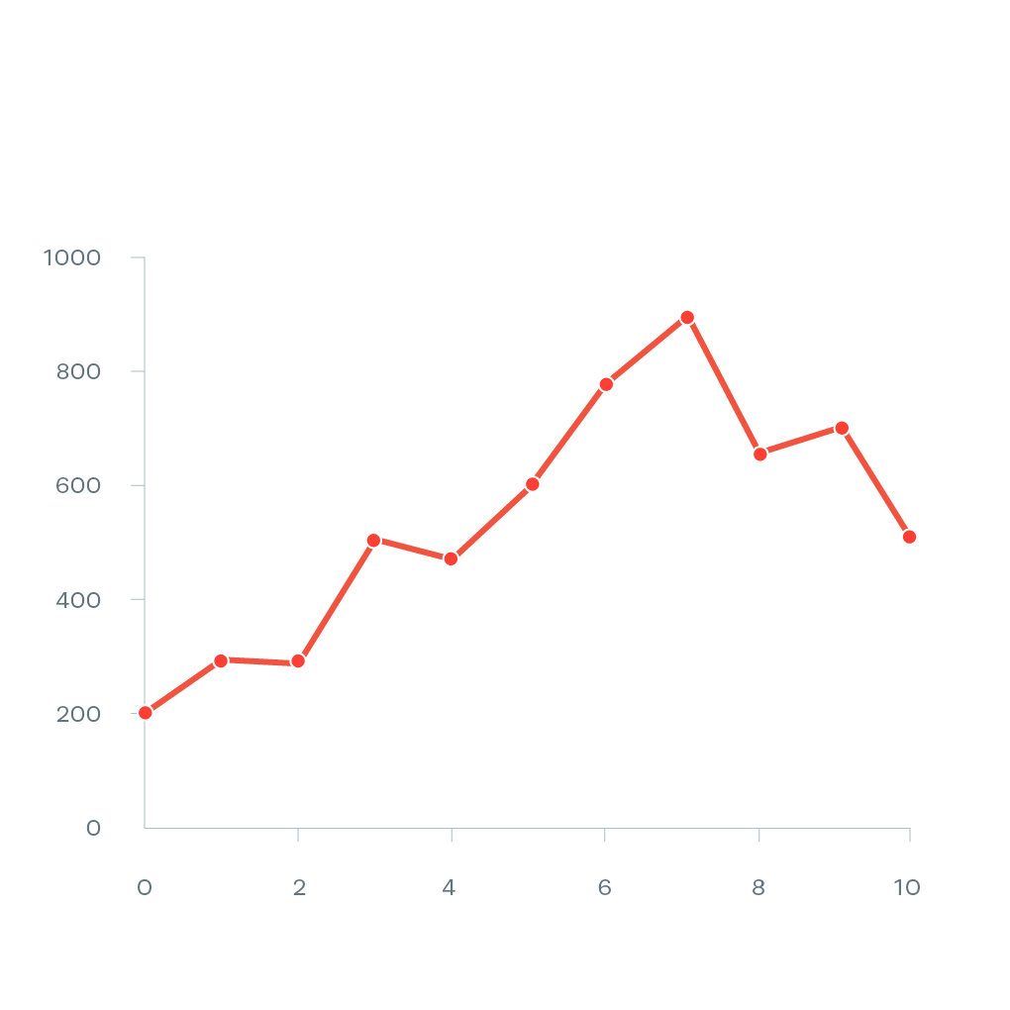

OUTPUT SCREEN SHOTS

APPENDIX II
KEY PERFORMANCE INDICATORS (KPI SECTION)
Include the following KPIs that highlight achievements and external recognitions associated with your project:
Key Performance Indicators
- Research Professional Practice
  - Paper Publications (Title, Journal/Conference, Year)
  - Patent Publications (Title, Patent Number, Year)
  - 1.3. Project Proposals submitted (Govt/ NGO/ Others)
  - Community Service Projects (Title, Impact, Year)
- Competition / Funding
2.1.Hackathon Participation (Event Name, Year, Achievements)
2.2. Project-Based Competitions (Event Name, Year, Rank/Achievements)
2.3. Academic International Level Participation (Event Name, Country, Year, Achievements)
2.4. Grant / Funding Received
2.5. Shortlisted for 2nd Round of Project Expo (Year)
2.6. Real-Time Validation of Project Idea (Description, Year)
2.7. Project Progression (Ideathon 5.0 to Solveathon 5.0)
2.8. Ideathon and Innovation Challenges (Event Name, Year, Rank/Achievements)
3. Startup / Entrepreneurship
3.1. Startup Registered
3.2. Under any Incubation Support
3.3. Project Proposals and Grants (Title, Funding Agency, Year)
3.4. iDEX Proposal Submission

APPENDIX III
JUSTIFICATION FOR POSITIVE (Productable, Opportunities, Sustainable, Informative, Technology, Innovative, Viable and Ethical)

S.No | PARAMETERS | JUSTIFICATION | RATING (1 to 5)
1. | Productable
2. | Opportunities
3. | Sustainable
4. | Informative
5. | Technology
6. | Innovative
7. | Viable
8. | Ethical

